Lab 3: USB_Image_Acquisition
What You Need for this lab
  - Install Virtualbox : https://www.virtualbox.org/wiki/Downloads
  - Install Kali 2021.4. : https://old.kali.org/kali-images/kali-2021.4/
    - Notes: Suggest You configure the disk size of Kali VM 80G because the size of each leakage cases image is 30G+
- FTK Imager for windows
https://accessdata.com/product-download/ftk-imager-version-4-5
- A flash drive
- The dd utility:
http://www.chrysocome.net/downloads/dd-0.5.zip
Step 1.
- Download and install FTK
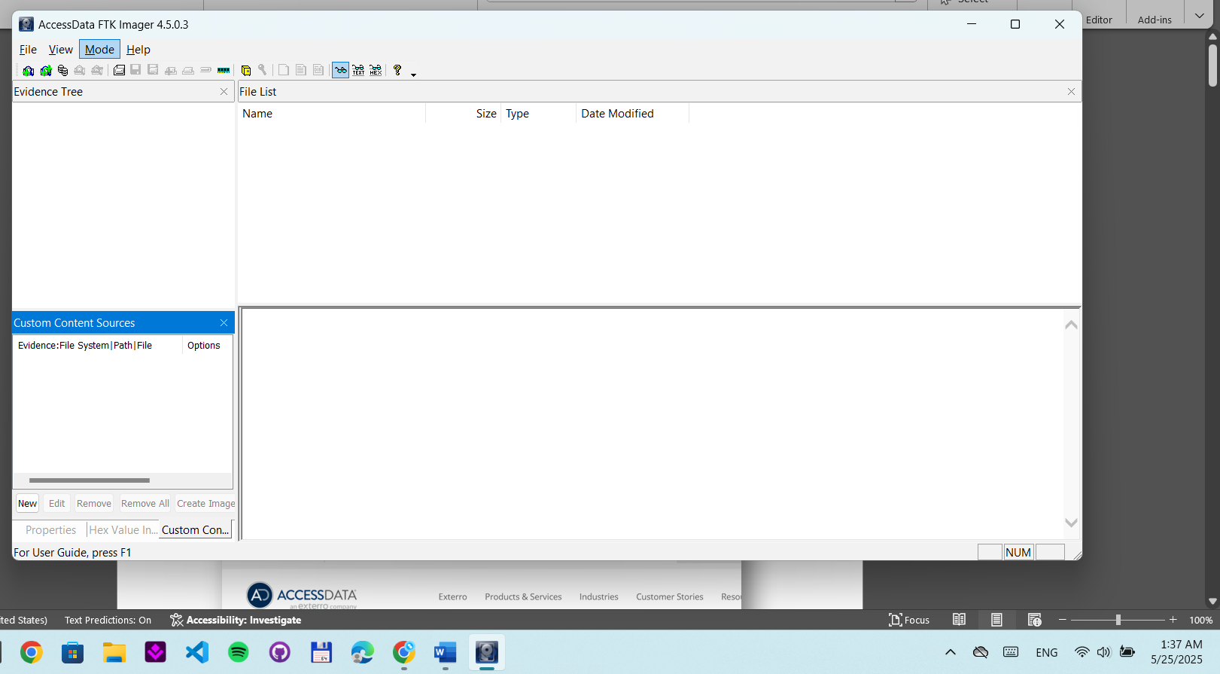
Step 2.
- Plug in a Flash Drive to your computer : you can copy come files to the USB.
- Verify your PC can read the USB drive
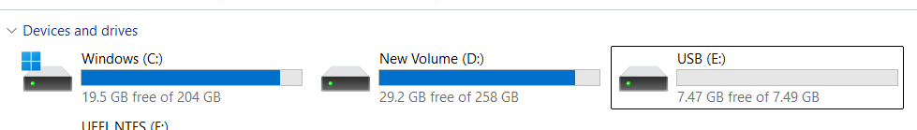
Step 3.
- Acquiring a USB using FTK
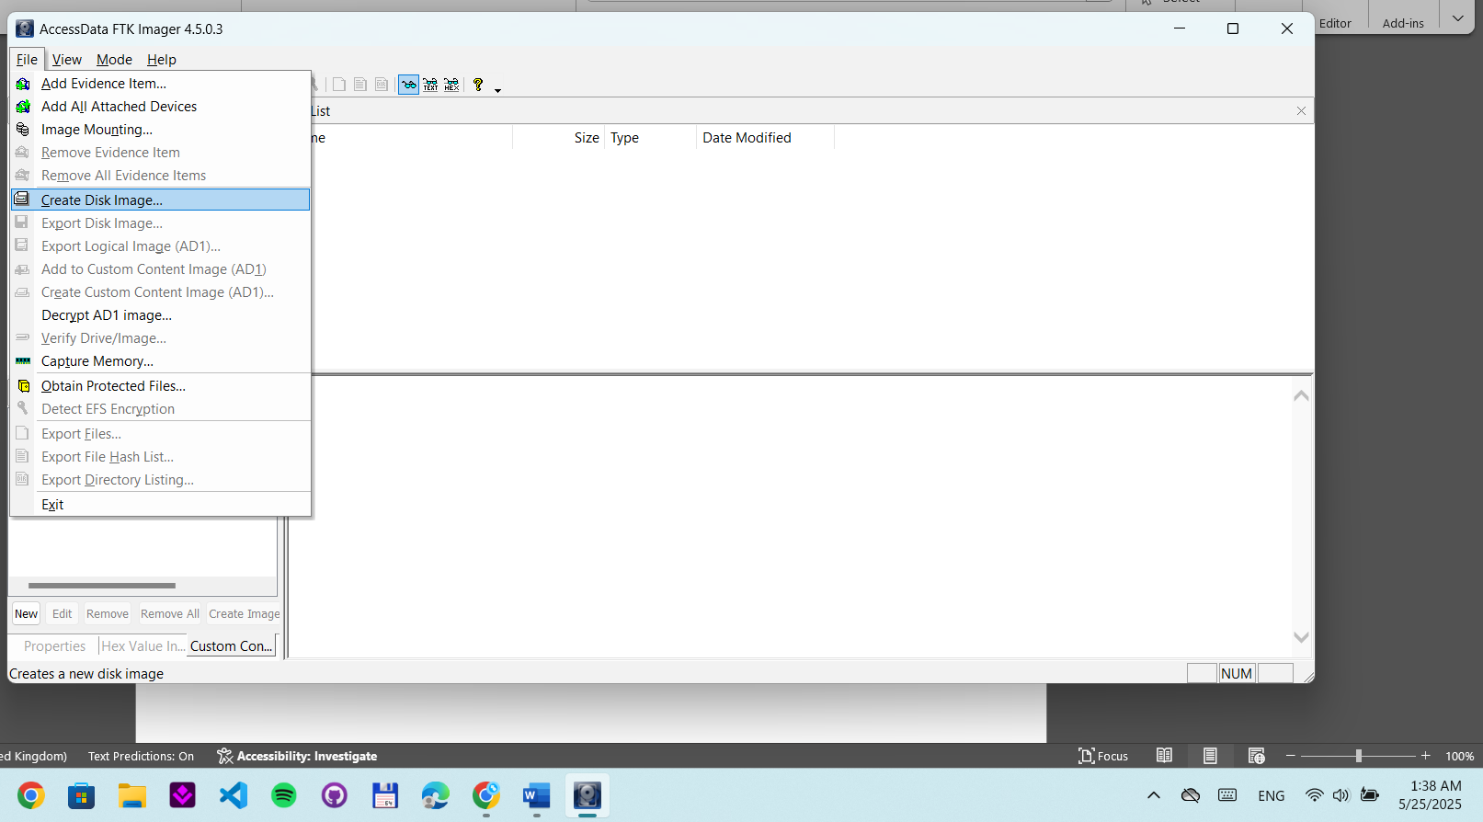

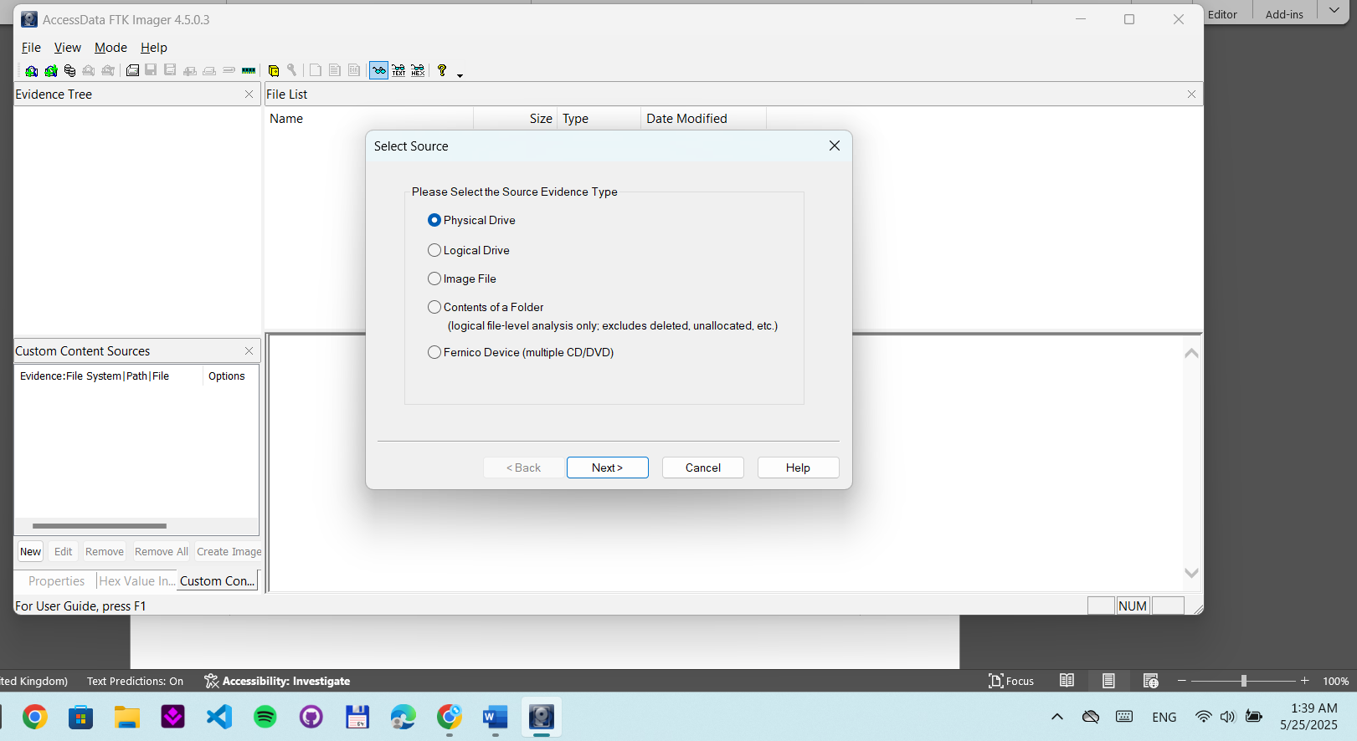

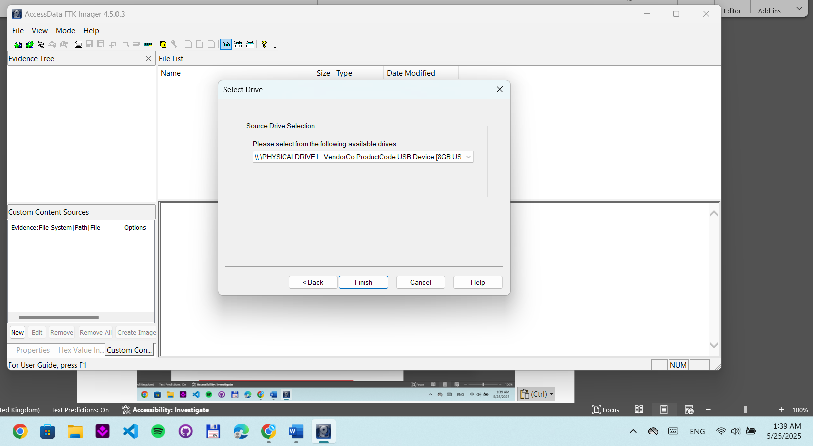

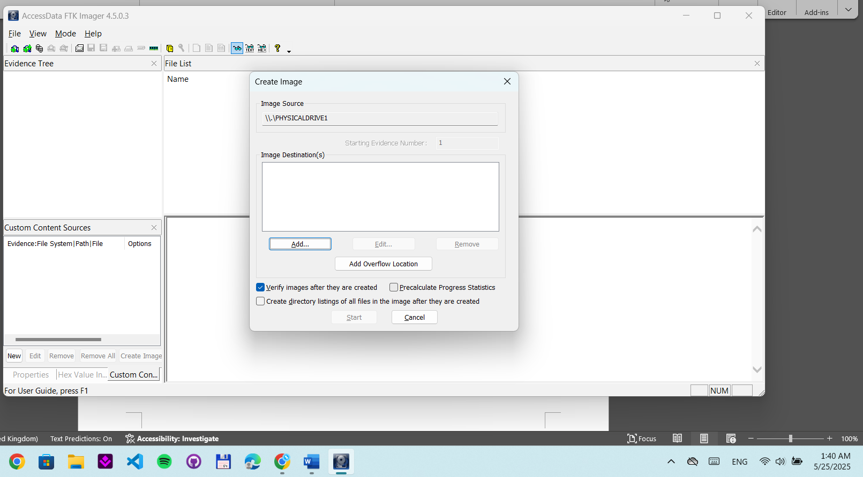

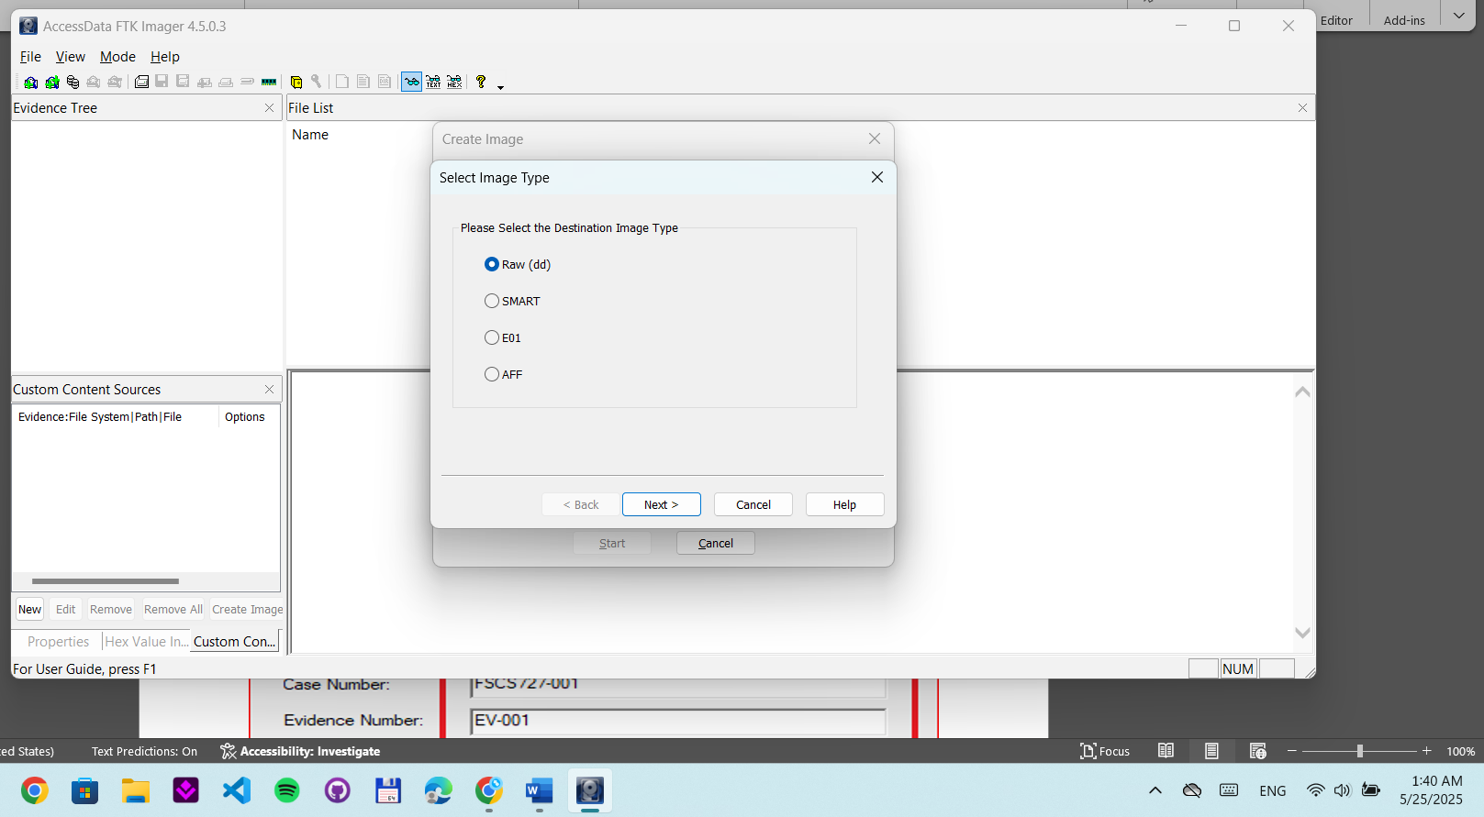

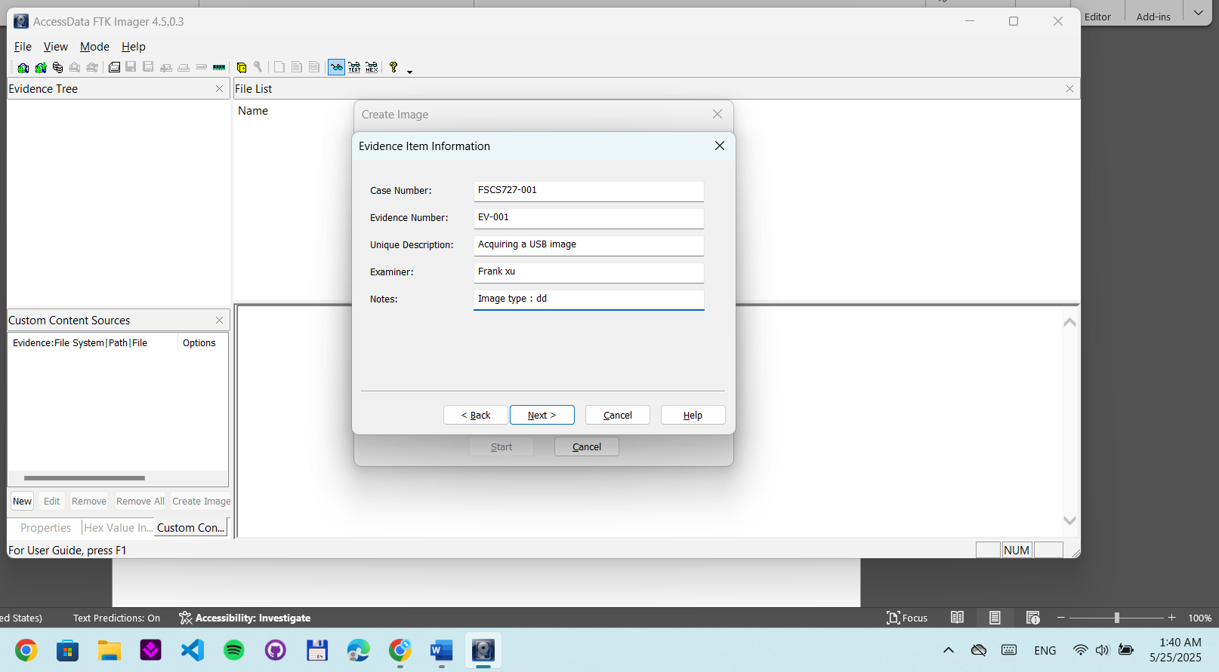

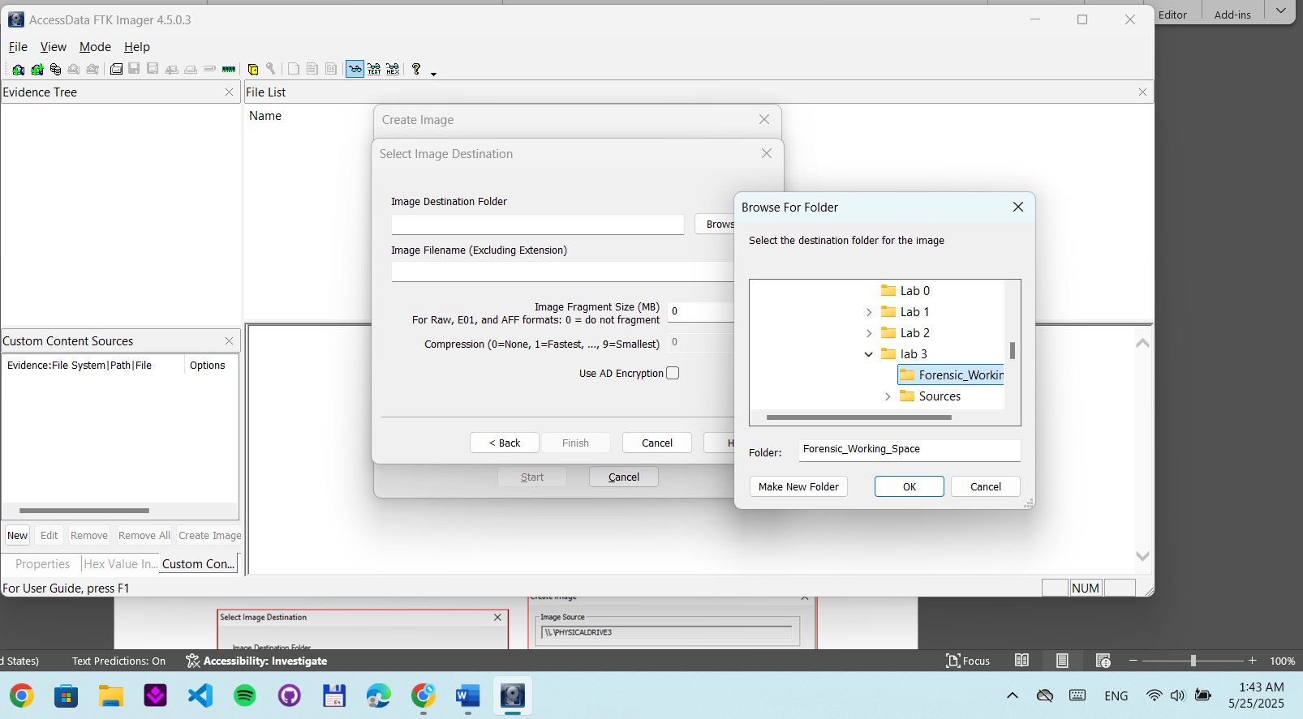

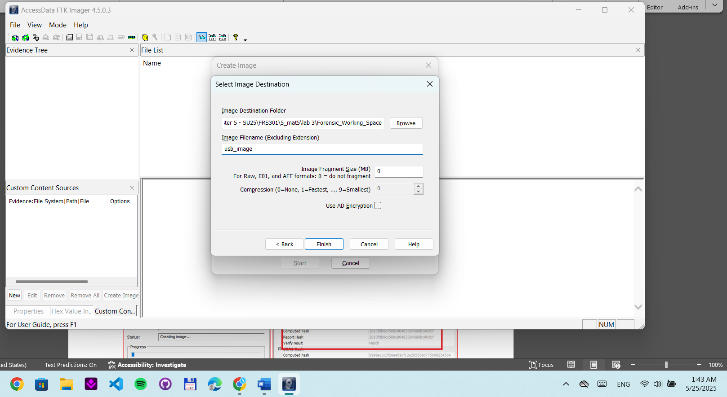
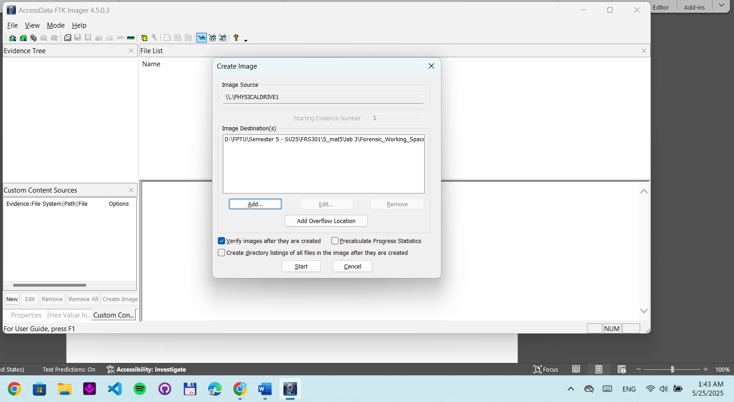
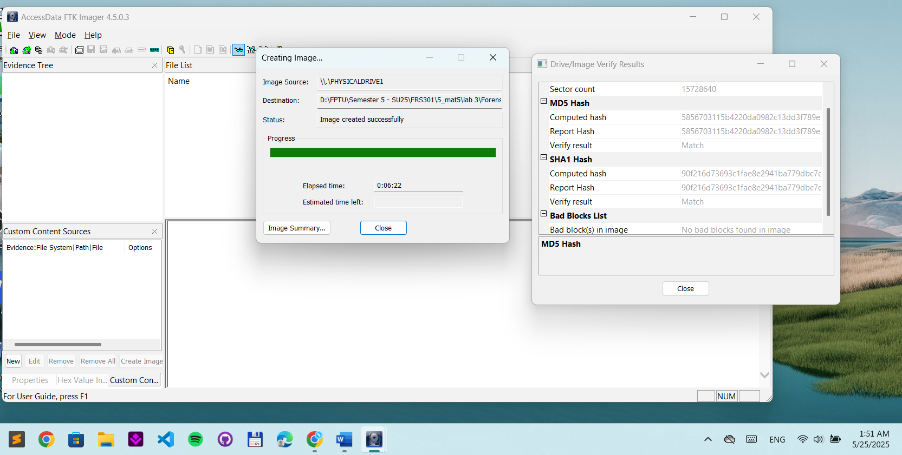
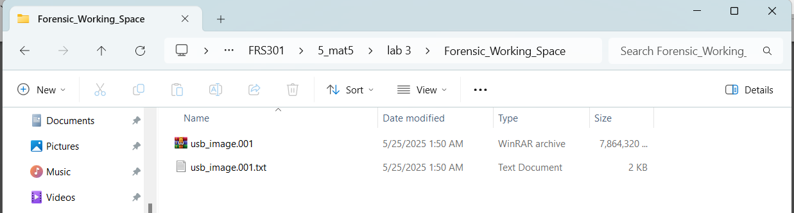

- Unzip dd utility and make a copy on your Desktop
- Check disks
  - dd --list
- Acquire the disk image
  - dd if=\\.\Volume{6d634efd-0000-0000-0000-501f00000000} of=c:\usb.img

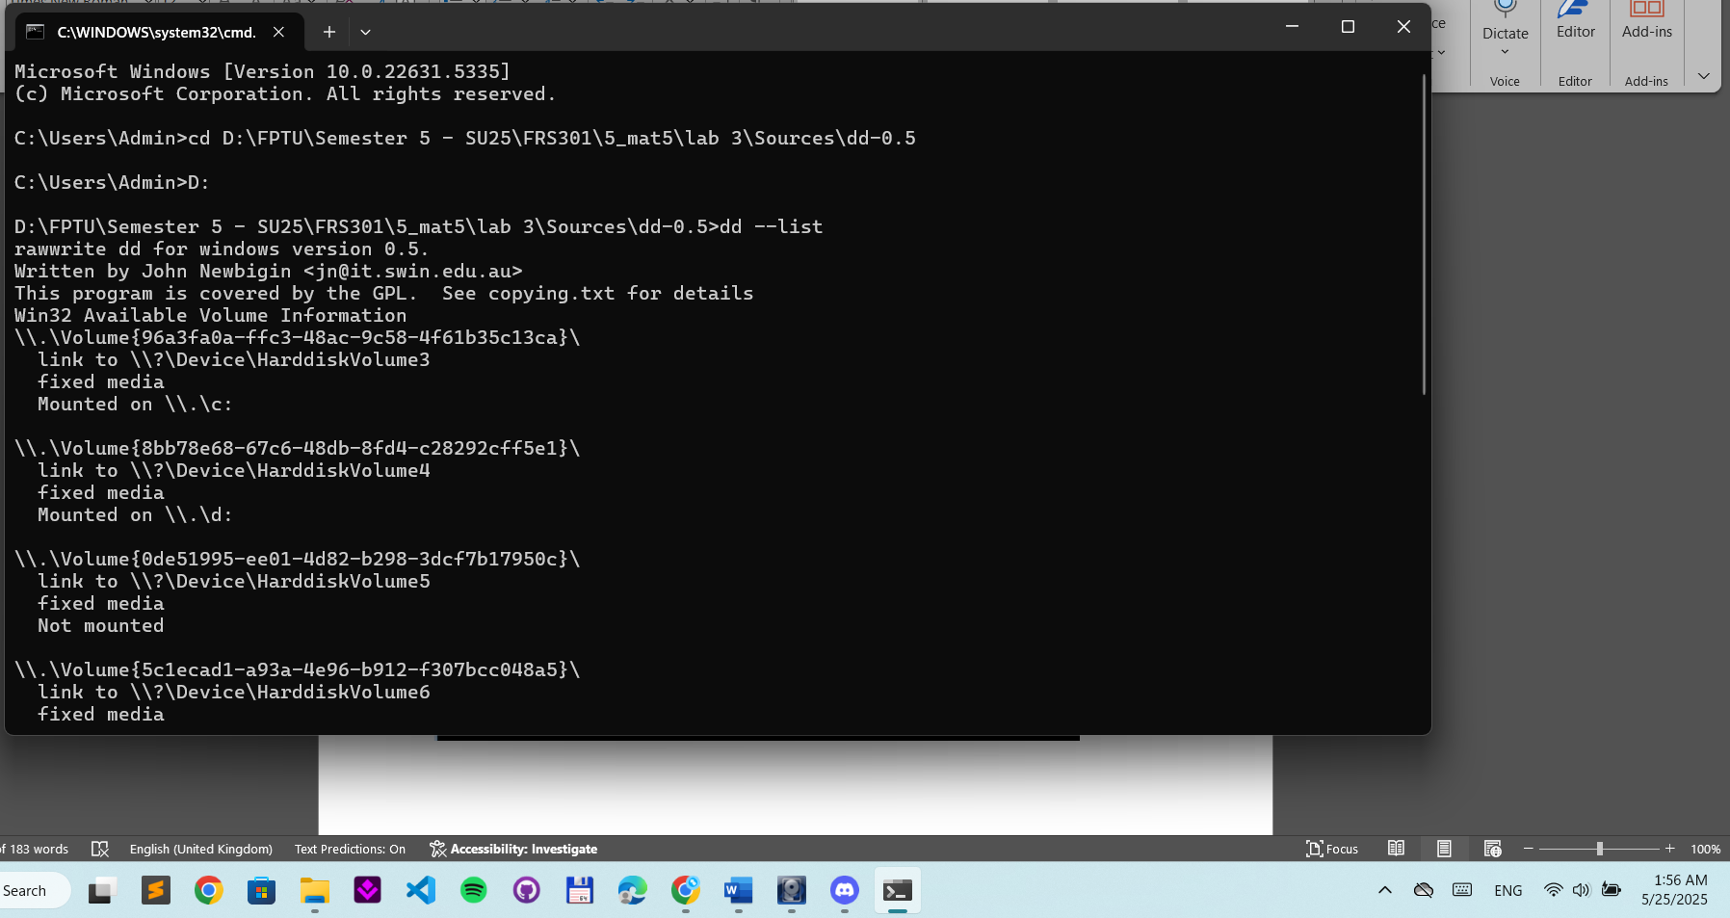

YOU MUST SUBMIT A FULL-SCREEN IMAGE FOR FULL CREDIT!
Save the document with the filename "YOUR NAME Lab 3.pdf", replacing "YOUR NAME" with your real name.
Email the image to the instructor as an attachment to an e-mail message. Send it to: xxx@fe.edu.vn with a subject line of "Lab 3 From YOUR NAME", replacing "YOUR NAME" with your real name.

